**Ions, ionic bonding and ionic substances 2023**

An **ion** is a **charged** particle. It is an atom which has lost or gained electrons

Non-metal atoms can gain electrons to become negative ions called ANIONS

Metal atoms can lose electrons to form positive ions called CATIONS

* When two ions of **opposite** charge combine an ionic compound is formed. The compound is called a binary ionic compound.
* **IONIC BOND** A bond formed between two ions by the transfer of electrons
* **Octet Rule** = atoms tend to gain, lose or share electrons so that they have a full shell of 8 electrons

Naming Ionic compounds

* When naming an ionic compound the *metal name comes first*
* *E.g. NaCl Sodium Chloride* ***anion*** *suffix endings become* ***-ide***
* *E.g2 NaF Sodium Fluoride*
* *Eg3 Na2O Sodium Oxide*

**Relationship between group number and charge**

|  |  |  |  |  |  |  |  |  |
| --- | --- | --- | --- | --- | --- | --- | --- | --- |
| **Group** | **1** | **2** | **3** | **4** | **5** | **6** | **7** | **8** |
| **Number of electrons in the outer shell of the atom**  **(valence electrons)** | **1** | **2** | **3** | **4** | **5** | **6** | **7** | **8** |
| IONIC  charge | +1 | +2 | +3 | +4  -4 | -3 | -2 | -1 | Stable, gp. 8 noble gases tend not to form ions |

**

**Properties of ionic compounds**

* FORM CRYSTAL LATTICES **-** which gives a specific shape to the crystals e.g. sodium chloride cubic, copper sulphate - Rhombus
* VERY HARD - each ion is bonded to several oppositely – charged ions
* HIGH MELTING POINTS - electrostatic attraction between ions positive cations and negative anions must be overcome before it melts.
* BRITTLE - with sufficient force, like charged ions are brought next to each other and repel. The crystal shatters
* CONDUCT ELECTRICITY- when dissolved or melted because the ions are freed. They do not conduct electricity as a solid

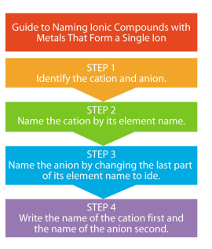[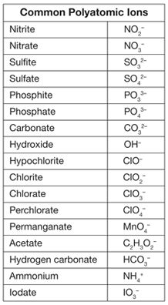](https://www.google.com.au/url?sa=i&rct=j&q=&esrc=s&source=images&cd=&cad=rja&uact=8&ved=0ahUKEwiT-r7E46_SAhXDVbwKHRCLBPMQjRwIBw&url=https://www.pinterest.com/explore/polyatomic-ion/&psig=AFQjCNETK499EcuKLEylBOaDoEQ-NWE7wg&ust=1488267740863046)

* **Polyatomic ions** or **Molecular** ions

are clusters of atoms that stay together as one unit

and carry an overall charge. (See the table for examples)

Most polyatomic ions are negatively charged.

You just have to learn poly atomic ions as you cannot work

out the charges from the periodic table. Compounds are named

by naming the metal followed by the poly atomic ion name.

|  |  |
| --- | --- |
| **Swap it and Drop it**   1. Write the chemical symbols. 2. Write the ionic charge of the symbols. 3. Swap it and Drop it. 4. Reduce – if necessary to make the number ratio as small as possible | 1. Sn CO3 2. Sn4+ (CO3)2- 3. Sn2(CO3)4 4. Sn(CO3)2 |

Iron (III) nitrate Fe (NO3)3

Sodium Nitrate Na(NO3)

Calcium Chlorate Ca(ClO3)2

Aluminum Sulphate Al2(SO4)3

**Write the ionic formula for the following Name these ionic compounds**

|  |  |
| --- | --- |
| 1) lead (II) sulfate  2) lead (IV) hydroxide  3) copper (II) chloride  4) beryllium Iodide  5) ammonium chloride  6) silver oxide  7) potassium sulphide  8) lithium carbonate  9) zinc sulphate  10) calcium hydroxide  11) aluminium nitrate  12) sodium phosphate  13) magnesium nitride  14) aluminium oxide  15) potassium iodide | 1) NaBr  2) NH4F  3) CaCO3  4) NiPO4  5) Li2SO3  6) Zn3P2  7) Cu2O  8) Ag3PO4  9) SnS2  10) Ti(CN)4  11) KMnO4  12) Pb3N2  13) CoCO3  14) Cu(NO2)2  15) Fe(HCO3)2 |